MANCHESTER AND DISTRICT WALKERS (MR50)

COMMITTEE MEETING

30th July 2025, 18.30

AGENDA AND REPORTS

Agenda item | Requested by
- Welcome | ES
- Apologies | LE
- Acceptance of minutes from previous meeting. | All
- Fixing future meeting dates – Vote for 1st or 2nd Wednesday of the month | ES / M
- Summer BBQ | CC
- Walk feedback form trial | EC

Outstanding actions from last meeting:
Edale MR Donation
Action NM to approve, is £250 appropriate based on funds?
Action KC gofundme to set this up/post on fb.
Next of Kin info
Action LE to post on FB about ICE cards and how to add emergency contact on your phone.
Action RP/ES to agree process for inputting next of kin on a form and what we would then do with that information.

Ongoing Actions
Action / Description
Women’s walk leader training – navigation training organized for Sat 16th March in Staveley. Limited numbers, but with idea that those who attend are new to navigation and bring back to the group what they have learned through walks and socials. (Separate to this, interesting to see a few navigation-focused socials on the calendar). ES to put on calendar once date confirmed.
Then ES/MVDZ to put on a walk leader training walk. ES - Idea to also do a navigation/walk ideas social – talk about routes/maps/navigation questions at a pub/bar (quiet enough to talk) in central Manchester – ONGOING (after training)
Walk leader training open to all. ES to ask Margaret about whether we can get funding/top-up from area funding - ONGOING

Young Ramblers weekend – SK and sub-committee met end of last year, started getting quotes. Date to be confirmed, but probably June/July.
Payment expected? Who else is on the committee? Action ES to check with SK, and get someone from the committee added to their whatsapp group.
Ramblers insurance – MP wrote a comprehensive summary of what her interpretation is of the rules, and summary is, it doesn’t apply. Action ES to check with Area.

ACTION 9 ES to check what we should / can minute on confidential matters – ongoing

ACTION 11 ES to get update from Joanna and Ed on footpath maintenance / volunteering. KC got some information from the BMC. Fix the fells (lakes) easier to do invasive clearance and moss planting than footpath maintenance. We could either organise a MAD specific thing, or use the calendar from a website of an organisation, and arrange a social. Don’t touch newts. Action ES.
ACTION 12 refresh the member stories on the website. JB to do a facebook callout.

REPORTS

Chair (Ellie)
Hello MAD walkers,
The last few months have been true to form for MAD, with plenty of walks, socials and weekends (with plenty coming in the pipeline).
An update on the Young Ramblers Weekend – we are looking at weekend of 25/26th October. There will be plenty of walk over the weekend and socials are to be confirmed, but hopefully one will include a tour round
Manchester (possibly with some monsters involved). When there is a better idea of activities, a call will go out to anyone who would like to help social or walks wise.

Secretary (Lottie)

Not much to report, its been a fairly quiet month for my secretary duties, thanks to all for your reports.

Walks Co Ordinator (Mike & Kim)
Over the last two months there have been 30 walks led by 22 leaders. This includes Phil Grundy and Matthew Wilders leading their first walks for the group. Half the walks were rated as Moderate, followed by Strenuous at 20%. We are however still seeing Easy and Leisurely walks, so we have a good mix. As the season of evening walks is well underway we are seeing representation from every day of the week, but Saturday is still the most popular with almost half of the walks. We have had success appealing for walk leaders on quieter weekends, which helps with both variety and ensuring no one leader is overrun.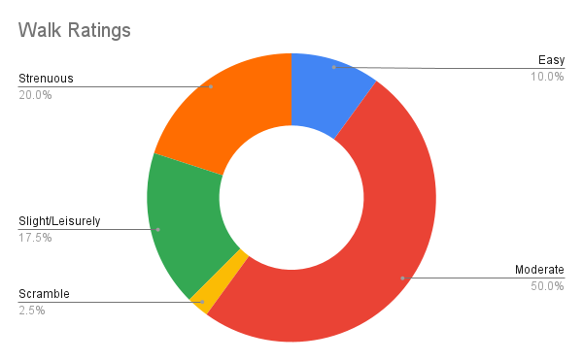 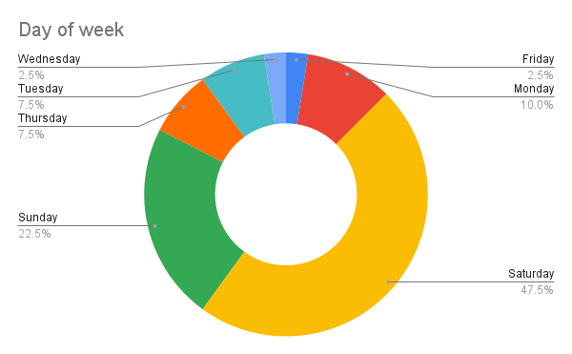
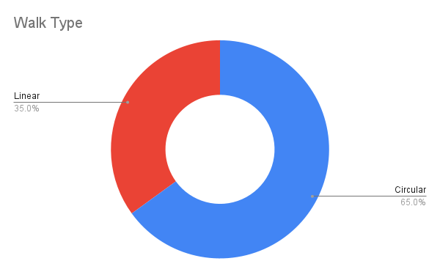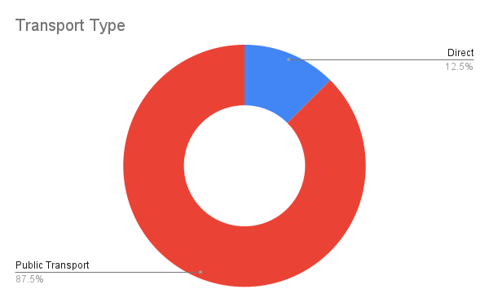

Membership Secretary (James)
According to the Ramblers Membership Insight Hub, as of 02/06/2025 we have 650 members. Since 02/03/2025 there have been 59 new members and 4 are showing as having re-joined.

The are currently 346 members of the MAD Walkers Members Facebook group (down from 375 at the time of my April report) as I removed those people I Identified as no longer being paid-up members of MAD on 20/05/2025. After giving notice a week earlier, there were a couple of re-joiners.

I’ll send another email soon to everyone who signed up for our walks and indicated on the form that they were not a member since my last Mailchimp email on 25/03/2025. I still need to seek advice from the Webmasters to attempt to keep the emails from people’s junk folders.

Treasurer (Natalie)
Treasurer (Natalie)
See below extract from the accounts updated 03/06/2025. The total currently stands as £7,011.24.
N.B: This increase in balance includes £1,068.40 that is ringfenced solely for the use of the Young Ramblers Weekend. This amount will need to be transferred to the Ramblers group that organises the next one after us.
Most transactional activity over the last 2 months has been for the following:
- Helvellyn weekend closed in a surplus - to which we offered a partial refund to attendees. For those that didn't require the refund - we have offered to make a donation to the local mountain rescue instead. This will be arranged shortly.
- The rest of the increase to the account is largely due to deposit payments for both the Malham DIY weekend meal, and initial sign ups for the Glencoe Weekend. We expect both of these to balance out in the near future.
Looking ahead, we will expect significant activity for the following:
- additional accommodation payments for Glencoe Weekend
- Meet up subscription (for next 6 months)
- Potential Summer BBQ social
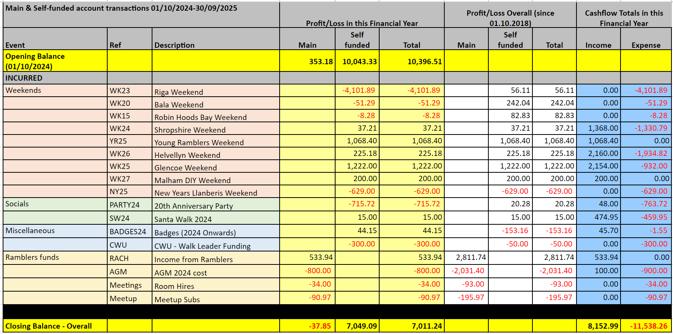

Social Secretary (Chip)
Not a huge amount to report upon since the last meeting in terms of socials. First suburban social of the year is now live. Still could do with more volunteers for the monthly drink social. Planned date for summer BBQ has had to be moved back to August due to a venue change.

Thanks,

Chip

Communications And Social Media (Katie and Ed)
On the Meetup front, the group continues to grow with 100 new joiners in the last 3 months. This brings our total Meetup members count to 3799.

Since February, I have only posted the monthly Sunday Stroll events on Meetup. This has worked reasonably well, acting as a source of publicity for the group while minimising disruption to MAD as a whole.

A recent change is that member reviews of our events on Meetup are now public. Unfortunately this is something we will need to keep an eye on - previously we have received negative reviews from members who arrived late and missed the start. Meetup does not allow admins to post responses to reviews - our only option is to report inappropriate feedback to Meetup. Our current rating on Meetup is 4.7/5 over 417 reviews.

Webmaster (Desi and Rob)
We've added the agenda and reports from previous months to the website now. A few inconsistencies were fixed in the walk submission forms (including Risk assessment links and minor copy and format changes). Asking new volunteers for their post code in the social submission form has been removed as not required. Frequently Asked Questions were updated in the email to the walk leaders to include how to deal with incidents on walks.
Rob has made a change and now the sign-up forms for walks with limited numbers of participants are opened automatically on the Monday (between 7 and 8pm) of the week they are scheduled. Let us know if you want that to be changed to 6-7pm instead. There were a few walks already of this type and the automation seems to work. As a result walk coordinator(s) no longer need to open the forms manually.

Best regards,
Desi & Rob

Weekends Co Ordinator (Miranda)

